Sowing seeds for endangered butterflies and plants
Does grassland community composition affect native plant establishment?

Project: C1112-11
Client: Katie Jones
Department: Botany & Plant Pathology
Major Professor: Tom Kaye
Degree: MS
Statistics experience: 511/512
Primary Consultant: Andrew Burkey
Secondary Consultant: Matthew Nahorniak

Background and Motivation:
An estimated 99.5% of the historic upland prairie ecosystem in Willamette Valley has been lost. The remaining patches are spread widely throughout the region. Because these patches of intact upland prairie have become biological islands, natural processes alone are no longer able to restore ecosystem processes and species. Active management, including vegetation manipulation and native species reintroduction, is necessary to restore and protect these habitats.
Through this research project, aspects of site and seed preparation are investigated as they apply to establishment of native perennial forbs by seed. The aim is to develop a set of scientifically tested tools to support land managers attempting restoration of upland prairie habitats and to enhance the likelihood that reintroduction of native plants will be successful.
This research focuses on five plant species: three endangered or threatened species—Kincaid’s lupine (Lupinus sulphureus ssp. kincaidii), Willamette daisy (Erigeron decumbens var. decumbens), golden paintbrush (Castilleja levisecta); and two common plant species—rose checkermallow (Sidalcea virgata) and roughleaf iris (Iris tenax). Three of these species are important for the endangered Fender’s blue butterfly (Icaricia icarioides fenderi).
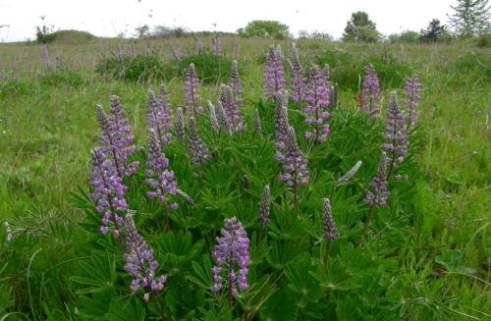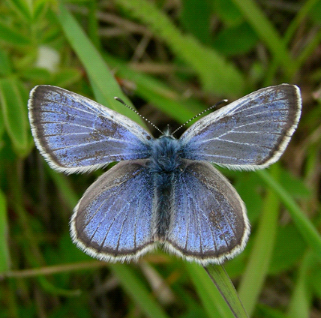
Kincaid’s lupine Fender’s blue butterfly
Main Objectives:
Understand the underlying science of habitat restoration in upland prairie ecosystems in order to successfully preserve upland prairie species and the upland prairie ecosystem in the Willamette Valley.
- Identify the relationship between invasive grass, associated litter and thatch and seedling establishment of the species tested.
- Determine if scarification of seeds with physical dormancy prior to field seeding increases establishment in experimental plots.
- Develop germination protocols for rose checkermallow and roughleaf iris.

Setup / Design:
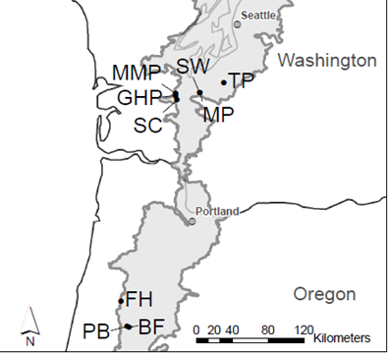
In 2005, a prior project, funded by the Priscilla Bullitt Collins Trust of the Nature Conservancy, employed a multi-site, multi-variable design to test the effectiveness of a variety of treatments side-by-side and in combination with one another. Treatments included the application of a grass-specific herbicide, spring or fall mowing, burning and application of a post-burn broad-spectrum herbicide, and seeding. The prior project concluded its work in 2007.
This project, started in 2009, uses the 3 sites from this project that are located in the Willamette Valley (Ft. Hoskins Historic Park; Pigeon Butte, Finley NWR; and Bellfountain, Finley NWR).
At each of the 3 sites, 20 of the established sites were randomly selected. Each of the sites was surveyed for existing cover in a 2m x 0.5 m plot. Each of these plots was divided into 4 equal 0.5m x 0.5m squares and she visually inspected each subdivision for percent cover of grass, forb, moss, litter, and thatch. Pictures of reference plots with known coverage percentages were used to aid in determination of coverage percentage. Additional community measures from prior project are available.

Treatment:
Each of the 60 plots is split in half and seeds/plugs are planted in each. The seeds in one half are scarified seeds and the other half are unscarified seeds. The side for scarified seeds is randomly selected.
Species | Seeds/plugs
Kincaid’s lupine | 100 seeds
Willamette daisy | 1000 seeds
Rose checkermallow | 100 seeds
Roughleaf iris | 100 seeds (plus 5 plugs)
Golden paintbrush (only at Bellfountain) | 5 plugs

Results:
After 1 year, establishment was measured:
Species | Establishment
Kincaid’s lupine | 26.5%
Willamette daisy | .0002%
Rose checkermallow | 18.5%
Roughleaf iris | 0%
Golden paintbrush (only at Bellfountain) | 95%

The first and second year, both the number of leaves and the presence/absence of grazing were recorded for each plant that was established. Stem length and longest leaf length were also measured on some of the species.

Further study:
Some seeds do not germinate readily when planted. As shown above, total establishment for iris in sampling plots was 0%. This establishment rate indicates that iris seeds may have some kind of dormancy. So, based on these results, dormancy breaking techniques for this species was investigated. The goal is to find a method to enhance their performance in the field.
For Iris tenax, warm and cold stratification is tested in a 3x7 factorial design. There will be a total of 21 treatment combinations; each treatment combination will be replicated 4 times using 50 seeds for each replicate. Warm stratification (20˚/30˚C) will be applied in three treatments, 0, 2 and 4 week intervals of warm conditions. Cold stratification (4˚C) will follow warm stratification and will be applied in 7 treatments ranging from 0-12 weeks of cold stratification in 2-week intervals. Following treatment application, seeds will be placed in a germination chamber (15˚/25˚C). Growth will be monitored weekly and recorded following a two-week germination period. Both the 20˚/30˚C and the 15˚/25˚C chambers have 8/16hr photoperiods, (8hrs of light, 16hrs of dark).
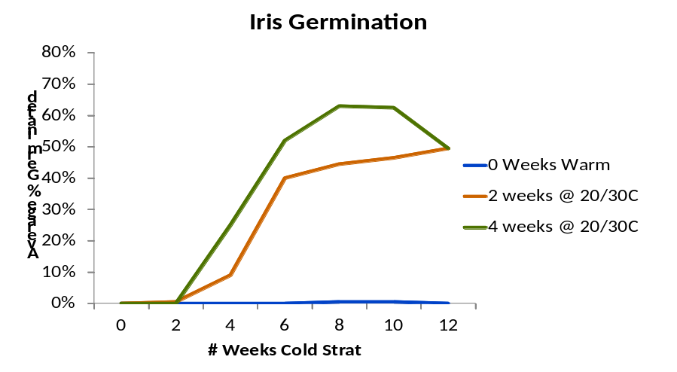
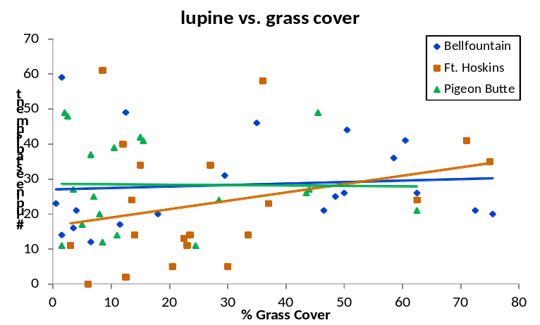
Initial analysis:
She has primarily done scatterplots of the data and run ANOVA tables and simple linear regression on her data.
Examples of initial plots shown at right.
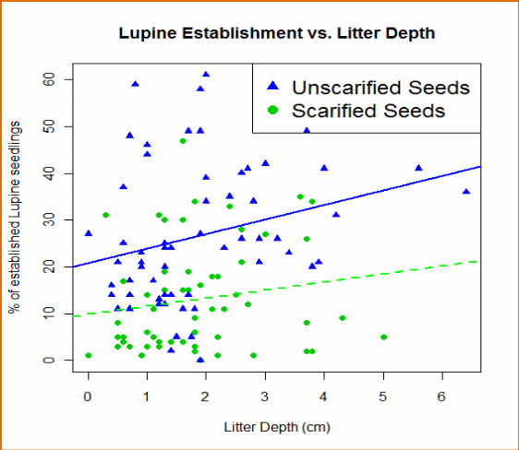
Client also realizes that scope of inference is limited to the 3 sites, due to the selection of the sites for study.

Assistance requested:
How best to organize and present all of this data. Help developing logical procedures for analyzing all of the different factors measured over time to determine the optimal conditions for plant survival – possibly different conditions for establishment and maturity.

Field Experiment:
Discussion:
It is possible that the different treatments from the Collins project may still influence the 5 species in the new experiment and the percent cover data that is collected in the subplots. It may be helpful to make some graphs of the cover data estimates collected from the plots in the current experiment with the treatments from the previous experiment. If future experiments are done on these plots, stratification or blocking by prior treatment is recommended,

Scarification studied in paired half-plots
The only variable manipulated in the field experiment is the scarification variable. These data have a nice pairing (scarified – unscarified) between the two half plots. A graph of establishment of scarified vs. unscarified seed for the same species from the paired half plots would give a good visual comparison. Could also look at a difference in scarified and unscarified from the same plot to see if the difference is equal to 0 or not. The data may need to be re-organized so that the establishment values for scarified / unscarified data are in separate columns for each species
Table 1. Example data structure. One line per plot (multivariate form)
year | Site | Plot | Lupine (Scar) | Lupine  (N-Scar) | Total Planted
2009 | Ft Hoskins | 1 | 21 | 40 | 100
2009 | Ft Hoskins | 2 | 18 | 23 | 100

Table 2. Data in two lines per plot (univariate form).
year | Site | Plot | Treatment | Lupine Established | Lupine Planted
2009 | Ft Hoskins | 1 | Scarified | 21 | 100
2009 | Ft Hoskins | 1 | Not scarified | 40 | 100
2009 | Ft Hoskins | 2 | Scarified | 18 | 100
2009 | Ft Hoskins | 2 | Not scarified | 23 | 100

If there are large differences visually between the scarified and non scarified groups, then you may want to analyze them separately (see 2 below). If you are going to analyze them together there are several options:

- The classic method is to take advantage of the pairs and the fact that each plot at each site is a 2x2 table with a total of 100 seeds (in the case of lupine):
Table 3. Example 2x2 table for a plot.

Established?  Scarified? | Yes | No | total
Yes | N11 | N12 | 100
No | N21 | N22 | 100

There are 20 such tables per site and the null hypothesis is that all of the tables have the same odds ratio. The odds ratio for the example table is (N11*N22) / (N12*N21). With the table set up as above, a positive value for the logarithm of the odds ratio for each plot means that scarified seeds have a higher proportion of plants germinating. Try plotting the log(odds ratio) for each plot with different symbols for each location (e.g., Ft. Hoskins=triangle, etc.) Is scarified consistently higher (log(odds ratio)>0)? Does it stay fairly constant within a location? Is there a shift in the log(odds ratio) from site to site? This can be explored initially with some graphs. If the log odds ratio is entirely >0 or <0 across all plots or sites, each scarification group may be analyzes separately because this would indicate that there is no interaction of scarification with plots or sites. In the past, data of this type were analyzed using the odds ratios and the Mantel-Haenszel Test (see the Statistical Sleuth, Chapter 19). Now logistic regression is used to model the proportions.

- Modeling proportion of established seeds
Probably only be looking at Kincaid’s Lupine and Rose Checkermallow because the other species exhibited so little variation (all germinated or none germinated). Proportion of counts tend to have a mean-variance relationship with the variance decreasing as the proportion approaches either zero or 1. Therefore, it generally makes sense to model such proportions using a modeling method for proportions. The most commonly used is some form of logistic regression – if the data are grouped, so that the response is in the form r/n where r is the number establishing out of, say, n=100 seeds, then overdispersion should be assessed relative to binomial variation. If there is evidence of overdispersion, switch from likelihood ratio tests (Chi-square distribution) in Maximum Likelihood to Quasilikeliihood F-tests where the overdispersion is measured by the deviance/df. See Chapter 21 in the Statistical Sleuth. If scarified and nonscarified seeds are being modeled together, there are two sources of overdispersion to check; between the paired halfplots, and from the same whole plot.

The establishment percentages between species from the same plot may not be independent due to competition among the plants, a scatterplot matrix showing all species would be useful to explore for possible interactions between species in terms of establishment rates. R code reference can be found at http://www.statmethods.net/graphs/scatterplot.html. What you are looking for are associations between establishment rates between species. For example, do plots with high establishment rates for Kincaid’s lupine tend to have low establishment rates for Rose checkermallow?
If there are differences between the scarification and no scarification then you can fit the statistical model separately for each group. If there is negative correlation between establishment rates between the species under study, then the establishment rate for other species should be included as a covariate in the model used to estimate associations with grass cover, litter, etc. Alternately, include all species establishment rates in a multivariate model.
A scatterplot matrix of establishment for each species versus all of the other variables measured on the subplots and community measures available from the previous study should also be examined.

How best to organize and present all of these data and help developing logical procedures for analyzing all of the different factors measured over time to determine the optimal conditions for plant survival?

Recommendations:
- Data organization.
  - Create a data set that is as granular as possible; each row consists of: Year, site name, plot number, half plot side, species name, scarified (Y/N), number of seeds planted, establishment count, %cover for grass, %cover for forbs, treatment category from prior project, community measures from prior project. See example in Table 1.
  - Create a second data set with year, site name, plot number, half plot side as before but where the species, scarification and establishment data are in separate columns for each combination. See example in Table2
- Logical procedure for analyzing data.
  - Make exploratory plots of scarification vs nonscarification taking advantage of the paired data in the half plots. If there are distinct differences between the members of the pairs, and they do not appear to interact with sites or plots, may want to analyze scarified and unscarified separately. Use data set form in Table 2 and the plot examples above as a guide.
  - Create a scatterplot matrix of establishment values for the different species (scarified/unscarified). Create scatterplot matrices of the establishment data versus the various possible predictors from each plot/half plot including the data from the previous study, as available. Use data set 2) above.
  - Examine the plots for patterns. Try to find answers to questions such as; are there any unusual values? Are there differences in establishment between scarified and unscarified within the same halfplots? Are the halfplot patterns with the covariates different? Are there any correlations between the predictor variables, either between the ones measured in this study or with those from the previous study? Are there any plots or subplots that appear unusual in their establishment data or in their predictor measurements?
  - The patterns and decisions from c) drive the next step, which is to begin fitting some statistical models to the data. It is best to look at years and sites separately at first. The decision to fit scarified and unscarified data separately or together will change the modeling procedure slightly as discussed below.

Fitting Scarified and Unscarified together
Using a univariate data set (example in Table 2) one can start doing logistic regression with paired data and allowing overdispersion. Use an indicator variable for including scarification in the model. http://www.statmethods.net/advstats/glm.html
A primary concern is overdispersion. First look at deviance over d.f. and can check significance of the ratio if >1 (this is sometimes used as a test for homogeneity of odds ratio). If dev/df >1 then can be conservative and use quasilikelihood (e.g. change family to quasibinomial) as described in the statistical sleuth Chapter 21.

Fitting Scarified and Unscarified separately.
Fit the same model as above but only include data from scarified or unscarified.

Bringing in measures such as litter depth as a predictor.
Is litter depth associated with overall survival? Plot mean survival of a plot (average over both scarified and unscarified) vs. litter depth with symbols for each location. Does the odds ratio (scarified over unscarified) change with litter depth in this sample? Plot the 20 logodds ratios (plot at location) against litter depth with location as symbols OR separate plot for each location (see Table 2 for odds ratio example and surrounding text for discussion). For the logistic regression model this is a visualization to address the question of whether a (litter depth) * (scarification indicator) is needed in the model. Start with the plots to understand the data and see where relationships appear linear or curvilinear and visually differ between locations.
Modeling: Using the logistic regression model again, add the predictors to the model statement. For example: If the additive site effect disappears once litter depth is in the model as a covariate, then one has a potential explanation for the additive site effect. Keep in mind that only associations between environment and plant establishment can be stated since this is an observational study. Causation cannot be established from these data alone.
Again, graphs will be important for this question if litter depth and other variables are added to the model in a linear fashion as opposed to a quadratic term (e.g., litter depth²).
Could also include (litter depth) * (scarification indicator) in the model to assess whether the difference between scarified and not scarified changes in a linear manner with litter depth. Diagnostic plots (residual and normality) from the model fit should be checked before interpreting p-values for model effects. Modifications to the models may need to be made and the models refit.

Iris Experiment
Discussion
Interest is in exploring factors that trigger the germination of Iris tenax.

Design Structure. The basic experimental unit is a set of 50 seeds, but more information is needed about the design structure to understand if the different factors in the treatment structure were all applied independently to this basic unit or not. Was each set processed separately or were there batches processed at the same time and then split? Chambers are mentioned in the notes, were groups of 50 seeds processes together in the chambers? There may be several different sizes or types of experimental units depending upon how the experiment is carried out. Were the 4 replicates processed together or were they processed on completely different days?

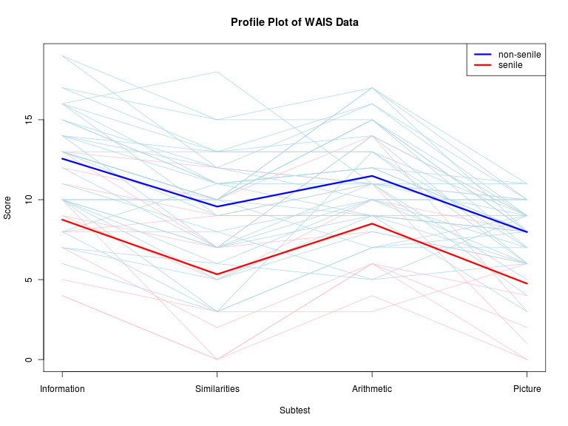
Recommendations: More information is need before fitting any statistical models as noted above. When doing the statistical model will want to use the variation between the sets of 50 to get at any extrabinomial variation (quasilikelihood is the simplest way, Sleuth chapter 21). For logistic regression type modeling it will be important to exclude treatments where all 4 reps give 0% germination because they are not of interest anyway (trying to maximize the germination) and they would bias the estimates of extrabinomial variation. Plotting the data can be done at this point. Profile plots for each individual set of 50 seeds will provide a useful first look at the data.
As in the field experiment, the responses for this lab experiment are grouped binomial data; the number of seeds germinating out of a sample of n (50 for all cases in this experiment).
The graph suggests that attempting to model all of the data together is not advisable. This is because 0 weeks warm had no germination at any week of cold. No reason to include the 0 weeks warm in modeling.
Use modeling to answer more subtle differences such as what is happening within the following subset of the data: 6, 8 and 10 weeks cold for 2 and 4 weeks warm (3 x 2 = 6 combinations) which include the highest germinating treatment combinations in the data set.

